W-16

12 PHYSICS ATAR

TEST 6 - MOMENTS AND EQUILIBRIUM

NAME: MARK: 

1. A drinking glass with a heavy base and straight sides is put on a sloping surface. When placed base down, it is stable, but when placed base up, it topples over. Using the diagrams, explain why this happens. (3 marks)

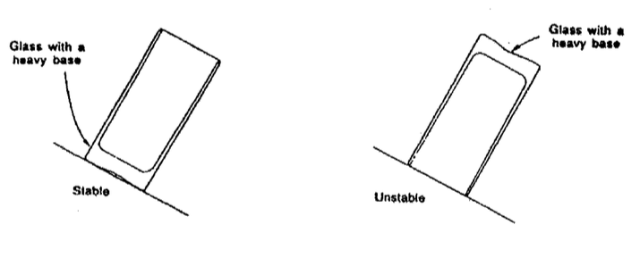

2. Bridgette has thought of a different way of measuring the mass of a plank. She has placed a mass of 2.00 kg on one end and a mass of 17.0 kg on the other. She finds the plank is balanced when pivoted at a point 2.90 m from the 2.00 kg mass. If the plank is 4.10 m long and uniform, what is its mass? (4 marks)

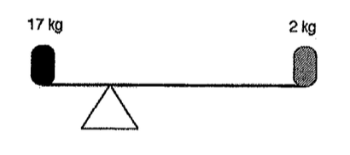

3. A small boy has a model aircraft of mass 1.10 kg suspended from the ceiling of his bedroom by two nylon fishing lines as shown in the diagram below. Determine the tension in each line.   (4 marks)

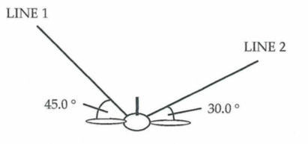

4. After sustaining an injury in a football match, a 1.80 m tall player is carried on a stretcher by two attendants, Simon and Paul. The mass of the player is 80.0 kg and the mass of the stretcher is 5.00 kg. The centre of mass of the player is 1.08 m from the player's feet. The centre of mass of the stretcher is 90.0 cm from the player's feet. Calculate the force that Simon and Paul exert as they carry the injured player.

(4 marks)

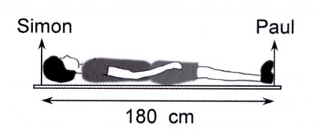

5. Cirque du Soleil travel the world performing under a Big Top. The performers and crew alike assist in erecting the structure around several large poles. The diagram below shows how a pole is raised.

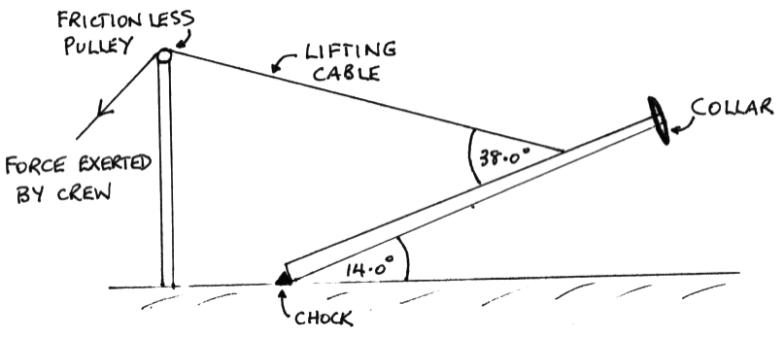

The pole is not uniform and has a mass of 3.20 x 102 kg. Its centre of mass is 4.20 m from the bottom. The collar at the top is 90.0 kg. A chock is used to stop the pole sliding across the ground as it is raised. The lifting cable is attached 3.00 m from the top and the pole forms a 14.0° angle to the ground at the instant shown. The pole is 10.0 m long.

(a) Calculate the tension in the lifting cable. (3 marks)

(b) What is the reaction force exerted by the chock onto the bottom of the pole.

(4 marks)